**Umngot River**

The small border town Dawki of Meghalaya is popular for its famous Umngot river and a beautiful suspension bridge. It is a major tourist destination in ...

Dawki Bridge, is a suspension bridge over the Umngot River. It was constructed in 1932 by the British. Water is so clear that underneath is visible.

One of the most remarkable natural landmarks in Meghalaya, Umngot River is a spectacle. With crystal clear water and view of the Bangladesh border, ...

1st image:

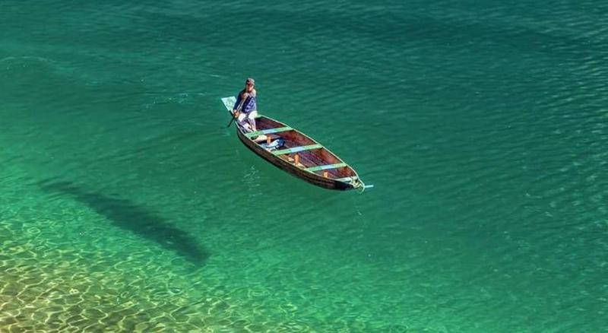

<https://d2np4vr8r37sds.cloudfront.net/book/13056-csggxpwssx-1618385702.jpeg>

2nd image:

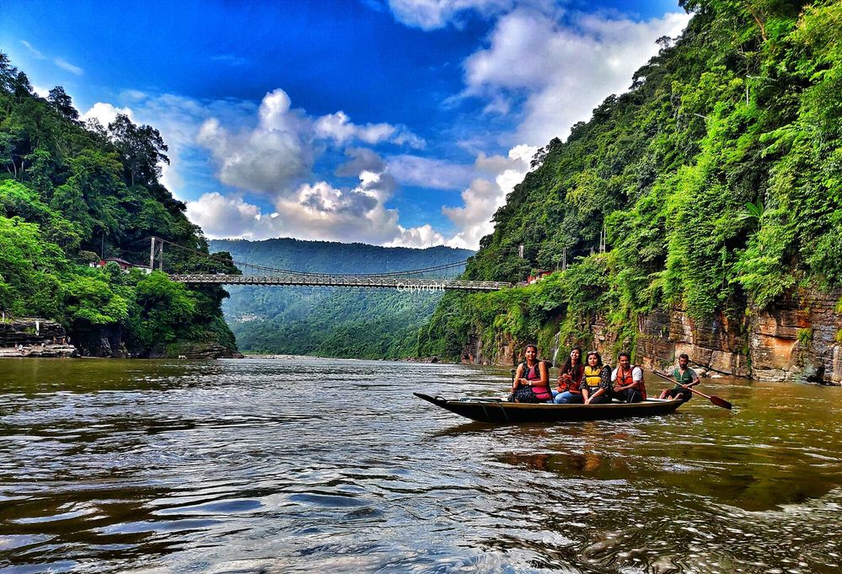

<https://www.localguidesconnect.com/t5/image/serverpage/image-id/462331i96CA8A03052CA894/image-size/large?v=v2&px=999>